Report for Deliverable 1. 14 (D1.14): Proposal for additional data rescue activities under EURO4M WP1.3

By Phil Jones¹, Roxana Bojariu², Manola Brunet ^{3 and 1}, Dimitrios Efthymiadis³, Alba Gilabert³

¹Climatic Research Unit, School of Environmental Sciences, University of East Anglia, Norwich, UK
²National Meteorological Administration (NMA-RO), Bucharest, Romania
³Centre for Climate Change, University Rovira i Virgili, Tarragona -43071-, Spain

Under the EU-FP7 Cooperation Theme 9: Space funded-project entitled European Reanalysis and Observations for Monitoring (EURO4M: Grant agreement no.: 242093), Work Package 1 (WP1) and sub-work package 1.3 (WP1.3) on Data Coordination and Access to National Archives has been produced the Deliverable 1.14: Proposal for additional data rescue.
The availability and scarcity of digitized long and high-quality surface climate records is still hampering our ability to better detect and predict future climate change. Countries are seeking to adapt to present and future impacts of climate variability and dangerous anthropogenic climate change over the European continent and its margins, and, thus availability is limiting our capacity for providing seamless and timely Global Monitoring for Environment and Security (GMES) services. This is particularly important over key but scarcely documented Europeans regions, such as the Balkans and Eastern European countries and southern and eastern Mediterranean countries.
In order to improve some of the restricted availability and accessibility to long climate records over these poorest documented European regions, EURO4M WP1.3 has been conducted a comprehensive survey of the potential for historical climate data recovery over these regions, as a first step for carrying out additional data rescue (DARE) activities.
This report gives detailed information on the activities carried out to locate, recover and develop long climate records over the poorest documented Mediterranean regions (southern and Eastern countries), the Balkan and Eastern Europe countries. These activities have been mainly completed by two EURO4M partners: University Rovira i Virgili (URV, Tarragona, Spain) and the National Meteorological Administration of Romania (NMA-RO, Bucharest, Romania).
The report is divided into two sections: 1) DARE activities required for data that have not yet been digitized over the Balkan and Eastern Europe, led by NMA-RO), and 2) Additional integrated data rescue (DARE) activities over southern and eastern Mediterranean countries, led by URV. In each section, we assess and give details of the sources and data holders used for identifying relevant historical climate data and provide a comprehensive list of the identified stations and their long climate records.
Section 1: Proposal for additional data rescue activities required for data that have not yet been digitized over the Balkan and Eastern Europe
1.1. Introduction
European and national funded projects, together with initiatives from international and national agencies, have increased the availability of historical climate data over Europe (mainly for air pressure, temperature and precipitation data). However, the current availability of historical surface climate data is still somewhat inadequate. This is particularly true over key but sparsely documented regions, such as Southern and Eastern Mediterranean, Balkans and Eastern Europe as well as for ECVs other than temperature and precipitation.
1.2. Sources for data rescue activities
Rescue activities for data that have not yet been digitized could provide opportunities for filling the gaps of surface climatological data and enhancing the availability of long-term/high-quality surface climate data at the finer temporal and spatial scales. For this purpose we have investigated the historical sources from the climatological archive of Romanian Meteorological Service. The Meteorological Service of Romania was established in 1884. The historical archive consists of climatic records and bulletins (daily and monthly ones) which could be used as sources for rescue data activities.
National Meteorological Data Records in digital format are organized and managed using a Climatological Database. The Climatological Database contains datasets from 1961 to date for all functioning stations. The National Meteorological Administration (NMA-RO) has carried out activities towards extending the current datasets with data prior to 1960. Within the framework of national funded projects, the Climatological Section together with Data Base Laboratory from NMA-RO has already digitized climatic records from 41 Romanian stations for their entire operational period. To preserve the archive documents NMA-RO has initiated the scanning of old documents. These scanned copies are stored on a central storage server to be used instead of paper documents (figure 1).
The daily climatic records prior to 1960 consist of observations made 3 times a day (8 h, 14 h, 20 h) and daily means. The main differences from present day climatic records (starting from 1960) are:
- pressure, water vapour tension and saturation deficit are in units mmHg;
- wind speed has units in the Beaufort scale;
- there are no observations of visibility, cloud type, dew point, soil temperature;
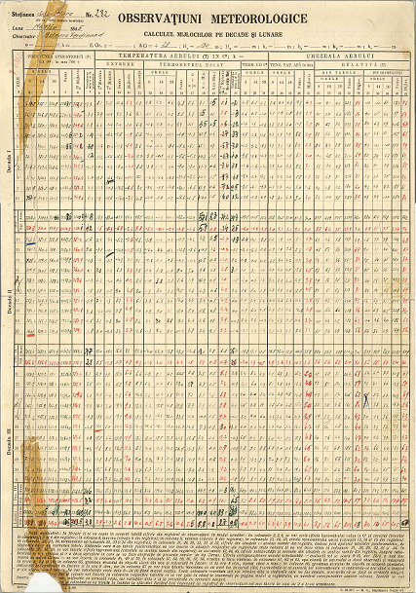
- there are daily mean values of pressure, water vapour tension and wind speed.

Figure 1: Example of a scanned climatic record at a station used as the source for digitized data.

Also, in addition to these standard records, the NMA-RO has old daily and monthly bulletins. The daily bulletins consist of pressure, temperature, sky description, weather description, wind speed and wind direction with observations 3 times a day together with pressure tendency, temperature tendency, precipitation and relative humidity at stations covering the Romanian territory as it was between the World War I and World War II. In addition the daily bulletins have pressure, temperature, sky description, wind speed and wind direction twice a day and mean temperate and precipitation from stations covering other Eastern European (Poland, Czechoslovakia, former USSR) and Balkan countries (former Yugoslavia, Bulgaria, Greece) and Southern and Eastern Mediterranean (Libya, Egypt). The daily bulletins span the period from 1925 to 1942. The sample of stations is not constant in time.
The monthly climatological bulletins consist of monthly climate summaries from climatic station and hydrological posts, such as:
- mean pressure
- pressure tendency from one day to another
- mean temperature
- mean daily minimum temperature
- mean daily maximum temperature
- thermal tendency from one day to another
- absolute maximum temperature and occurrence date
- absolute minimum temperature and occurrence date
- absolute and relative humidity
- total precipitation
- maximum precipitation in 24 h
- cloud cover (0-10)
- number of days with precipitation greater than 0.1 mm
- number of days with precipitation in snow form
- number of days with snow cover
- snow cover depth
- number of days with fog
- number of days with strong wind
- number of days with temperature less or equal with 0 C
- number of days with temperature greater or equal with 25 C
- number of days with temperature greater or equal with 30 C
- number of days with clear sky (0-3)
- number of cloudy days (4-7)
- number of covered sky (8-10)
- wind frequencies along directions
- calm frequencies
- sunshine duration
- maximum sunshine duration in a day
This type of monthly bulletin spans the period 1903-1950.

1.3. Proposal for additional data rescue activities
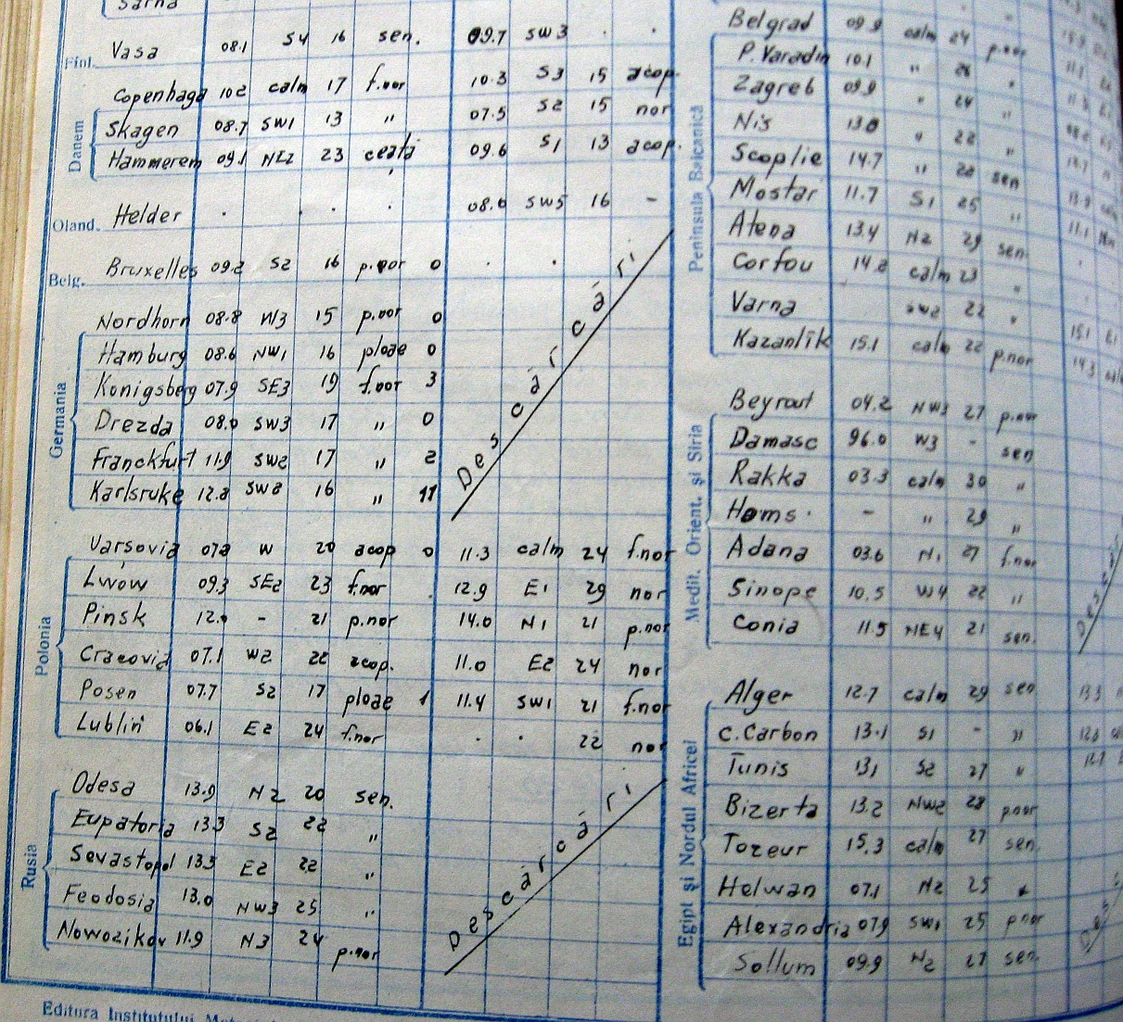
In the framework of the EURO4M project we propose to digitize and validate the records from 2 Romanian climatological stations with long-term observations, for their entire period of operation. In addition, we propose to digitize precipitation and snow depth data in the form of monthly catchment averages, extending their time series as much as possible from the monthly bulletins prior to 1960.
Figure 2: Example from daily bulletin (15th of July 1931) with pressure, wind speed and direction, temperature, sky description and precipitation at 7 h and 18 h from stations in Europe, Northern Africa and Middle East.
These monthly bulletins are a sound source for 16 catchment averages for intervals prior to 1960 over Romanian territory and some of its neighbouring areas. They could be further used in WP3 as climatic indices relevant for potential users and stakeholders. Monthly values of snow cover depths and number of days with snow cover from stations Cernovcy, Kisinev, Izmail and Komrat could add data spanning roughly from 1921 to 1942 to the data at these stations which have been already digitized in the Former Soviet Union Hydrological Snow Surveys for the period 1966-1996 (Krenke, 1998).
Also, the daily bulletins could be used as alternative sources to fill some gaps in digitized data (pressure, temperature, precipitation, wind speed and direction, sky description) and improve their quality over regions from Eastern Europe, Balkan and Southern and Eastern Mediterranean areas (figure 2).
Section 2: Additional integrated data rescue activities over Southern and Eastern Mediterranean countries
2.1. Introduction
Although meteorological observations were regularly taken in the past over Southern and Eastern Mediterranean countries from as early as the first half of the 19th century, current availability and accessibility for usable digital climate data in global and regional climate datasets (e.g. GHCN-D or the ECA&D) is dramatically restricted to recent decades (mainly from the 1970s onwards) and shows a sparse spatial distribution. Both Mediterranean sub-regions are among the world regions that are somewhat poorly documented, which is impeding the development of optimum strategies to mitigate and/or adapt to the negative impacts of global climate change over a region that is considered as a climate change “hot spot” (Giorgi, 2006).
In order to increase both availability and accessibility to vital historical climate data over these sparsely documented Mediterranean sub-regions, we propose a list of stations, climate variable records (e.g. daily maximum and minimum temperature, daily accumulated precipitation and hourly air surface pressure) and target periods for developing high-quality and long climate records that should enable us to enhance our scientific knowledge on climate variability and change and its impacts over these sub-regions.
The initial activities will lead to the development of an additional data rescue inventory encompassing searches of both on-line data holders and national and international archives, in order to locate and gain access to relevant climate data and metadata over North African, Middle East and Mediterranean countries, which will also be the target of the activities undertaken under EURO4M WP1.3.
2.1. Data holders and sources explored for additional DARE activities over Southern and Eastern Mediterranean countries
We undertook, first, on-line searches of relevant data holders and providers for locating and recovering both imaged and digitised historical and present climate data and metadata for the countries located in the Southern and Eastern Mediterranean Basin. This enabled us to define the set of daily and hourly climate records to be targeted by WP1.3.
The main data holders and providers accessed for getting current digital data, on which to base the selection of the historical records to be recovered, digitised and developed, included the following ones:
- The KNMI ECA&D (http://eca.knmi.nl/) from where we collected the currently available daily temperature and precipitation records for southern and eastern Mediterranean stations
- The International Surface Pressure Databank (ISPD: ftp://ftp.ncdc.noaa.gov/pub/data/ispd/) developed under the auspices of the Global Climate Observing System (GCOS) Working Group on Surface Pressure and the World Climate Research Program WCRP/GCOS Working Group on Observational Data Sets for Reanalysis by NOAA Earth System Research Laboratory (ESRL), NOAA's NCDC, and the Climate Diagnostics Center (CDC) of the University of Colorado's Cooperative Institute for Research in Environmental Sciences (CIRES)
- The Spanish Agencia Estatal de Meteorología (AEMet, the Spanish Met Office: http://www.aemet.es/es/portada and ftp://ftpdatos.aemet.es/), from where past and current digital data recorded in both former and current Spanish enclaves of North Morocco were recovered
- The Climate Change and Impact Research: the Mediterranean Environment (CIRCE FP6-Integrated Project: http://www.circeproject.eu/index.php), where digitised daily climate data over Tunisian locations were brought.
- The World Meteorological Organization (WMO) MEditerranean DAta REscue (MEDARE) Initiative (http://app.omm.urv.cat/urv/), from where both metadata and digital climate data were collected.
- From National Meteorological and Hydrological Services (NMHS) over the targeted Mediterranean countries under MEDARE umbrella.
Other data holders and providers of imaged/scanned climate data and metadata were also searched for accessing to their holdings, as listed below:
- The NOAA/NCDC Climate Data Modernization Project (CDMP: http://docs.lib.noaa.gov/rescue/data_rescue_home.html), where most of the located and recovered stations data come from.
- The Météo-France (http://france.meteofrance.com/) archives (ftp://ftp.meteo.fr/) where historical observations were taken overseas
- The Atmospheric Circulation Reconstructions over the Earth (ACRE) project (http://badc.nerc.ac.uk/browse/badc/corral/images/metobs), from where climate data for a few relevant stations located in Cyprus and Egypt is being collected.
- Zentral Anstalt für Meteorologie und Geodynamik (ZAMG: http://www.zamg.ac.at/), whose archives contain sources with relevant data over the Middle East countries.
We also undertook searches in a few physical Archives and Libraries in order to locate further sources of climate data that enable us to infill in gaps and missing periods for stations and records recovered from other on-line data sources. Searches have been conducted in Météo-France Library in Paris, by staff of this meteorological service, and in Ebro’s Observatory (EO) Library (Tortosa, Spain), with the latter returning an abundant number of relevant data sources.
From the inspected data holders, the following data sources have been explored. They are listed in alphabetical order, giving details on the data sources’ titles, countries and locations names and periods covered by each source:
American University of Beirut (Syrian Protestant College) / Lee Observatory (from NCDC/CDMP;http://docs.lib.noaa.gov/rescue/data_rescue_lebanon.html). Series titles: Meteorological Register of Syrian Protestant College, Beirut, Syria (1891–1911), Monthly bulletin of the observatory. Syrian Protestant College, Beirut, Syria (1912–1915), Monthly bulletin of the observatory. American University Observatory, Beirut, Syria/Lebanon (1921–1940, 1942–1958), Monthly bulletin. Meteorological section. American University Observatory, Beirut, Lebanon (1959–1975). Sites covered in Lebanon and Syria
Annales du Bureau Central Météorologique de France; (Paris, Gauthier-Villars).
Periods covered by this source held in NCDC/CDMP (http://docs.lib.noaa.gov/rescue/data_rescue_french.html): 1877–1882, 1888–1898, 1900–1904, 1907–1908, and 1910–1913; for same source at EO: 1883–1887, 1899, 1905–1906 and 1914; and from Météo-France: 1909. Several sites covered in Morocco, Algeria, Tunisia, Egypt, Palestine, Syria/Lebanon
Annuaire de la Société Météorologique de France; (Paris, Au lieu des Séances de la Societé). Periods covered by this source held at Météo-France: 1849–1884, 1900–1924, and from the volume of 1861 held at EO: 1857-1860. Relevant information is for Oran (Algeria).
Austrian Year Books (held at ZAMG) covering the 1854–1984 period and the following station: Alexandria, 1882–1896
Bolletino Meteorologico della Cirenaica held at NCDC/CDMP (http://docs.lib.noaa.gov/rescue/data_rescue_libya.html) and mainly covering the 1927–1931 period and sites in Eastern Libya.
Bollettino Meteorologico dell'Africa Italiana at NCDC/CDMP (http://docs.lib.noaa.gov/rescue/data_rescue_italian.html) and mainly covering the 1932–1936 period for sites in Libya.
Bulletin Météorologique de l'Algerie at NCDC/CDMP (http://docs.lib.noaa.gov/rescue/data_rescue_algeria.html), covering the periods: 1877–1890, 1892–1893, 1895, 1897–1917, 1919–1938 and stations in Morocco, Algeria, Tunisia
Bulletin quotidien de reseignements météorologique du Maroc. From the source held at NCDC/CDMP (http://docs.lib.noaa.gov/rescue/data_rescue_morocco.html), the periods covered are 1953–1968, 1977–1978 and from the volumes held at Météo-France archives the period 1953–1991, covering sites for Morocco and Algeria.
Cairo. Meteorological Report, held at NCDC/CDMP (http://docs.lib.noaa.gov/rescue/data_rescue_egypt.html), covering the periods: 1900–1926, 1931–1940 and for stations over Egypt.
Egypt. Daily Weather Report, held at NCDC/CDMP (http://docs.lib.noaa.gov/rescue/data_rescue_egypt.html), covering the periods: 1907–1922, 1924–1940, 1945–1957 and for sites in Egypt.
Egypt. Monthly Weather Report; Egypt (Cairo, Egyptian Meteorological Authority), climate data for 1957-1963 from the source held at NCDC/CDMP (http://docs.lib.noaa.gov/rescue/data_rescue_egypt.html) and for 1956-1962 and 1973-1981 from the volumes held at EO for sites in Egypt (Giza, Tahrir)
Helwan. Meteorological Report, Royal Observatory Helwan; Egypt (Cairo, National Printing Department). Period covered by NCDC/CDMP (http://docs.lib.noaa.gov/rescue/data_rescue_egypt.html) holdings: 1942–1947, 1952–1953; and by EO holdings: 1909-1932 and 1942-1953. All of them contain climate data for Helwan (Cairo region, Egypt)
Israel. Monthly Weather Report, held at NCDC/CDMP (http://docs.lib.noaa.gov/rescue/data_rescue_palestine.html) and including data for the 1947–1947, 1949–1972 and 1975–1975 periods for sites in Israel
Ksara. Observatoire de Ksara, (B. Berloty, Observatoire de Ksara publications), held at EO, and containing data for 1910 (may) – 1912 (des) for this Lebanese location
Ksara. Annales de l'Observatoire de Ksara, Dirigé par les PP. de la Compagnie de Jesús. Periods covered by this source held in NCDC/CDMP (http://docs.lib.noaa.gov/rescue/data_rescue_lebanon.html): 1921-1939; for same source at EO for the 1922 – 1939 period.
Ksara. Annales climatologiques de l'Observatoire de Ksara (Beyrouth, Imprimerie Catholique de Beyrouth). Periods covered by this source held in NCDC/CDMP (http://docs.lib.noaa.gov/rescue/data_rescue_lebanon.html): 1957-1971; for same source at EO with data for the periods 1957-1973 for this site.
Lebanon. Bulletin Climatologique Mensual (Service Central meteorologique), held at NCDC/CDMP (http://docs.lib.noaa.gov/rescue/data_rescue_lebanon.html), including data for 1928–1941 and 1944–1970 for sites in Lebanon and Syria.
Service Météorologique de Tunis, held at NCDC/CDMP (http://docs.lib.noaa.gov/rescue/data_rescue_tunisia.html). Periods covered are 1907–1911 and 1921–1932 for sites in Tunisia
Syria. Monthly Climatological Data (United Arab Republic, Ministry of war, Meteorological departament), held at NCDC/CDMP (http://docs.lib.noaa.gov/rescue/data_rescue_syria.html). Periods covered are 1955–1959, 1962–1975 for stations in Syria.
Tableau Climatologique Mensuel. Series A, held at MEDARE database, covering the period 1874–2009 for the following Algerian stations and specific periods: Skikda-Cap Bougarouni, 1921–1980; Bejaia-Cap Carbon, 1910–1975; Laghouat-Aflou DSA, 1874–2009.
Tableau Climatologique Mensuel. Series B, held at Météo-France, including data for the 1899–1938 and 1944–1963 periods and for the following Tunisian stations: Bizerte - Cap Blanc: 1899–1938, 1958–1963; Bizerte - Karouba: 1920–1936, 1944–1959; Bizerte - Roland Garros: 1951–1963; Tunis-el-Aouina: 1925–1936, 1946–1957; Jendouba: 1946–1957; Kairouan: 1930–1936, 1946–1957; Gafsa: 1931–1936, 1945–1957; Sfax: 1946–1957; Gabes: 1925–1936, 1946–1957
UK Climatological Returns (from ACRE project), the following countries, stations and specific periods are available: For Morocco: Cape Spartel (Tanger region) for the 1894–1920 period. For Cyprus: Nicosia General Hospital, 1901–1922; Nicosia Observatory: 1907–1910; Paphos G. Hospital, 1901–1922 and Paphos Ktima, 1901–1922. For Egypt: Alexandria, 1901–1904. For Syria: Mount Lebanon, 1890–1904.
UK Daily Weather Reports (from ACRE project). Climate data for the following Libyan stations: Tripoli, 1916–1920; Benghasi, 1927–1930 and Egyptian sites: Mersa Matruh, 1923–1930; Cairo, 1916–1930; Alexandria, 1916–1922.
2.2. Proposal for additional climate data rescue activities over Southern and Eastern Mediterranean countries
The searches of relevant data holders and sources returned a rich heritage of historical climate data and weather observations that is held in usable format (e.g. imaged data and metadata) and showed the potential for carrying out data rescue activities, the development of high-quality climate data over the targeted Mediterranean sub-regions. Once digitized, this will increase the availability and accessibility to data that is key for developing more robust climate products and services for better securing safety and quality of people’s life.
The rationale for the selection of the additional list of historical climate records for the targeted Mediterranean countries relies on both ensuring availability of current digitised data and on different spatial and temporal criteria, such as well-spatially distributed stations, length of records and their completeness. Table 1 shows the additional list of targeted variable records, locations and periods to be rescued under EURO4M WP1.3.
Table 1: List of the records targeted for digitisation over Southern and Eastern Mediterranean countries, giving station names and WMO identifier codes, climate variables and periods.
Country | Station name & WMO code | Daily Tmax/Tmin | Daily Rainfall | Hourly Air Pressure
Morocco | TANGER AIRPORT 60101 | 1962–1966 | 1962–1968 | 1962–1968  1977–1978
Morocco | AL HOCEIMA 60107 | 1965–1968  1977–1978 | 1965–1968  1977–1978 | 1965–1968  1977–1978
Morocco | OUJDA 60115 | 1910–1917  1919–1934  1953–1968 | 1910–1917  1919–1934  1953–1968 | 1953–1968
Morocco | TETUAN/SANIA RAMEL 60318 | 1959–1963  1977–1978 | 1968  1977–1978
Algeria | SKIKDA-CAP BOUGAROUNI 60355.1 | 1921–1980
Algeria | LA CALLE / EL-KALA 60367 |  |  | 1881–1884  1886–1886  1881–1882
1877–1890
1892–1893
1897–1909
1922–1938
 | ALGER-VILLE 60369 | 1877–1884  1885–1890  1892–1893  1895–1895  1897–1917 | 1880–1884  1885–1890  1892–1893  1895–1895  1897–1917 | 1877–1880  1885–1890  1892–1893  1895–1895  1897–1917  1919–1938
 | BEJAIA-CAP CARBON 60400 | 1910–1975
 | SETIF 60445 | 1878–1882  1886–1890  1892–1893  1895–1895  1910–1917  1919–1938 | 1878–1885  1886–1890  1892–1893  1895–1895  1910–1917  1919–1938 | 1878–1885  1886–1890  1892–1893  1895–1895  1910–1917  1919–1938
 | ORAN-HOPITAL MILITAIRE 60461.1 | 1856–1860  1884–1895  1897–1917  1919–1919  1922–1924  1927–1938 | 1856–1860  1880–1885  1886–1890  1892–1893  1895–1895  1897–1917  1919–1919  1922–1924  1927–1938 | 1856–1860  1880–1885  1886–1890  1892–1893  1895–1895  1897–1917  1919–1919  1922–1924  1927–1938
Tunisia | BIZERTE 60714 | 1879–1904  1897–1917  1919–1922  1929–1932 | 1879–1904  1897–1917  1919–1922  1921–1932 | 1879–1904  1897–1917  1919–1922  1929–1932
Tunisia | TUNIS-CARTHAGE 60715 | 1886–1889  1892–1893  1895–1895  1897–1917  1919–1938 | 1878–1884  1886–1889  1892–1893  1897–1917  1919–1938
Tunisia | KELIBIA 60720 |  | 1907–1911  1921–1932
Tunisia | SFAX / EL-MAOU 60750 | 1886–1890  1892–1893  1895–1895  1897–1917  1919–1938 | 1878–1881  1886–1890  1892–1893  1895–1895  1897–1917  1919–1938 | 1878–1881  1886–1890  1892–1893  1895–1895  1897–1917  1919–1938
Tunisia | TOZEUR 60760.1 | 1897–1909  1919–1938 | 1897–1909  1919–1938 | 1897–1909  1919–1938
Tunisia | DJERBA MELLITA 60769 | 1897–1910 | 1897–1910  1907–1911  1921–1932
Libya | NALUT 62002 | 1932–1936  1943–1955 | 1943–1955
Libya | ZUARA 62007 | 1932–1936  1951–1955 | 1951–1955
Libya | TRIPOLI AIRPORT | 1943–1955 | 1943–1955 | 1943–1950
 | 62010
 | TRIPOLI OLD CITY 62011 | 1932–1936 | 1932–1936
 | Azizia 62010.1 | 1932–1932 | 1920–1947 | 1943–1960
 | MISURATA 62016 | 1932–1936  1937–1940  1949–1956 | 1937–1940  1949–1956 | 1932–1936  1951–1969
 | SIRTE 62019 | 1932–1936  1937–1940  1946–1955 | 1937–1940  1946–1955
 | BENGAZI CITY 62053.1 | 1927–1931  1932–1936  1936–1941 | 1927–1931  1932–1936  1936–1941
 | BENGAZI BENINA 62053 | 1944–1955 | 1944–1955 | 1937–1940
 | AGEDABIA 62055 | 1928–1931  1932–1936  1936–1938  1952–1955 | 1936–1938  1952–1955 | 1927–1931  1932–1936  1936–1941
 | SHAHAT 62056 | 1952–1955 | 1952–1955 | 1947–1947
 | CIRENE 62056.1 | 1928–1931  1932–1936
 | DERNA 62059 | 1920–1925  1927–1936  1952–1955 | 1920–1925  1927–1936  1952–1955
Egypt | MERSA MATRUH 62306 | 1920–1922  1923–1923  1924–1940  1945–1957 | 1920–1922  1923–1923  1924–1940  1945–1957 | 1925–1940  1945–1945  1949–1957
Egypt | ALEXANDRIA 62319 | 1882–1896  1901–1904  1907–1922  1924–1940  1945–1957 | 1882–1896  1901–1904  1907–1922  1924–1940  1945–1957 | 1920–1922  1923–1923  1925–1940  1945–1957
Egypt | PORT SAID CITY 62333 | 1883–1886  1887–1905  1906–1908  1907–1922  1924–1940  1945–1957 | 1883–1886  1887–1905  1906–1908  1907–1922  1924–1940  1945–1957
Egypt | CAIRO H.Q. / ABBASSIA OBSERV 62371 | 1900–1903  1906–1908  1916–1930 | 1900–1903  1906–1908  1916–1930 | 1882–1896  1901–1904  1907–1922  1924–1940  1945–1957
Egypt | CAIRO EZBEKIYA 62374 | 1930–1940  1945–1957 | 1930–1940  1945–1957
Egypt | GIZA 62375 | 1907–1922  1924–1940  1945–1957  1957–1963 | 1907–1922  1924–1940  1945–1957  1957–1963 | 1883–1886  1887–1905  1906–1908  1907–1922  1924–1940  1945–1957
Egypt | HELWAN 62378 | 1907–1922  1924–1940  1945–1957 | 1907–1922  1924–1940  1945–1957
Egypt | FAYOUM 62381 | 1932–1940  1949–1957 | 1932–1940  1949–1957
Egypt | SIWA 62417 | 1911–1926  1924–1940  1945–1957 | 1919–1920  1921–1922  1924–1940
Egypt | EL SUEZ 62450 | 1907–1922  1924–1940  1945–1957 | 1907–1922  1924–1940  1945–1957
Egypt | ISMAILIA CITY 62441 | 1883–1886  1888–1898  1901–1904  1911–1913  1948–1957 | 1883–1886  1888–1898  1901–1904  1911–1913  1948–1957 | 1913–1918  1932–1940  1945–1957
Syria | JARABLUS 40005 | 1957–1959  1975–1975 | 1928–1939  1957–1959  1975–1975
Syria | ALEPPO 40007 | 1955–1959  1962–1975 | 1913–1915  1933–1941  1944–1956  1955–1959  1962–1975 | 1930–1940  1945–1957
Syria | LATTAKIA 40022 | 1928–1930  1962–1975 | 1928–1940  1944–1945  1962–1975 | 1907–1922  1924–1940  1945–1957  1957–1963
Syria | TARTOUS 40050 |  | 1928–1929  1931–1941  1957–1959  1975–1975 | 1932–1940  1949–1957
Syria | HOMS 40055 | 1928–1930  1955–1959  1975–1975 | 1913–1915  1928–1930  1932–1932  1934–1935  1937–1940  1944–1945  1955–1959 | 1927–1931  1932–1940  1945–1957
Syria | PALMYRA 40061 | 1928–1930  1955–1959 | 1928–1930  1934–1935  1937–1941  1944–1946  1955–1959 | 1906–1922  1924–1940  1945–1957
Syria | DAMASCUS CITY 40078.1 40080 | 1928–1930  1970–1975 | 1912–1915  1928–1941  1944–1948  1970–1975 | 1911–1926  1924–1937
Syria | DARA'A 40095 | 1928–1930  1932–1932  1975–1975 | 1913–1915  1928–1930  1932–1932  1975–1975 | 1883–1886  1888–1898  1901–1904  1911–1913  1948–1957
Syria | RAYACK 40102 |  | 1928–1930  1932–1941  1944–1970
Lebanon | TRIPOLI CITY (QLAIAAT) 40103; 40103.1 |  | 1931–1935  1937–1941  1944–1959  1959–1970
Lebanon | AL-ARZ (LES CEDRES 40105 |  | 1937–1941  1947–1950  1957–1970
Lebanon | KSARA OBSERVATOIRE 40106 | 1912–1913  1921–1939 | 1912–1913  1914–1915  1921–1939  1928–1941  1944–1970
Lebanon | HERMEL 40108.1 |  | 1932–1934  1936–1940  1944–1970
Lebanon | RACHAYA 40109.1 |  | 1933–1941  1945–1970
Cyprus | Nicosia, | 1880–1922  1942–1974 | 1880–1922  1942–1974
Cyprus | Paphos | 1881–1922  1947–1984 | 1881–1922  1947–1984

References

Giorgi, F. 2006. Climate change hot-spots, Geophys. Res. Lett., 33, L08707, doi:10.1029/2006GL025734.
Krenke, A. 1998, updated 2004. Former Soviet Union Hydrological Snow Surveys, 1966-1996. Edited by NSIDC. Boulder, CO: National Snow and Ice Data Center/World Data Center for Glaciology. Digital media. http://nsidc.org/data/docs/noaa/g01170_fsu_snow/index.html

The Global Historical Climatology Network-Daily from the US National Climate Data Center (NCDC)/National Ocean and Atmosphere Administration (NOAA): http://www.ncdc.noaa.gov/oa/climate/ghcn-daily/
The European Climate Assessment & Dataset held at the Royal Netherlands Meteorological Institute (KNMI): http://eca.knmi.nl/

